EXPT NO: 4 | TRANSFER LEARNING USING PRE-TRAINED VISION MODELS FOR IMAGE RECOGNITION
DATE:

PRE-LAB QUESTIONS (PROVIDE BRIEF ANSWERS TO THE FOLLOWING QUESTIONS)

- What is transfer learning in deep learning?
Transfer learning is a technique where a pre-trained deep learning model is reused for a new but related task. Instead of training the entire model from the beginning, the learned features are transferred and adapted to the new dataset, reducing training time and computational requirements.

- What are the advantages of using pre-trained models over training from scratch?
Pre-trained models save training time and computational resources because they already contain useful learned features. They generally require less training data and fewer epochs to achieve good accuracy. They also provide better performance and reduce the difficulty of building a deep learning model from scratch.

- What is the role of fine-tuning in transfer learning?
Fine-tuning involves unfreezing some layers of a pre-trained model and training them further on the new dataset. It helps the model adapt its learned features to the specific characteristics of the new task, potentially improving accuracy while requiring less training than building a model from scratch.

- Name any three popular pre-trained computer vision models.
Three popular pre-trained computer vision models are ResNet-50, AlexNet, and VGG16. These models are trained on large image datasets and can be reused for different image recognition and classification tasks through transfer learning, reducing the amount of training required for a new computer vision application.

- What is the purpose of Hugging Face and how is it useful in deep learning?
Hugging Face provides a platform and libraries containing many pre-trained deep learning models and datasets. It simplifies loading, using, and experimenting with models for tasks such as image classification and natural language processing, making deep learning model development faster and easier.

AIM
To implement transfer learning using pre-trained vision models for image recognition and evaluate their performance on real-world image datasets.

SOFTWARE REQUIREMENTS
- Python
- TensorFlow/Keras or PyTorch
- Google Colab
- Hugging Face Transformers
- Kaggle Dataset
- Matplotlib
- GitHub

OBJECTIVES
Students will be able to:
- Understand the concept of transfer learning.
- Apply pre-trained vision models for image recognition.
- Fine-tune models such as ResNet or AlexNet.
- Utilize Kaggle datasets and Hugging Face vision models.
- Compare transfer learning performance with custom CNN models.

Task A: DATASET PREPARATION
Perform the following tasks:
- Download an image dataset from Kaggle.
- Load and preprocess the images.
- Split the dataset into training, validation, and testing sets.

Code and Output:
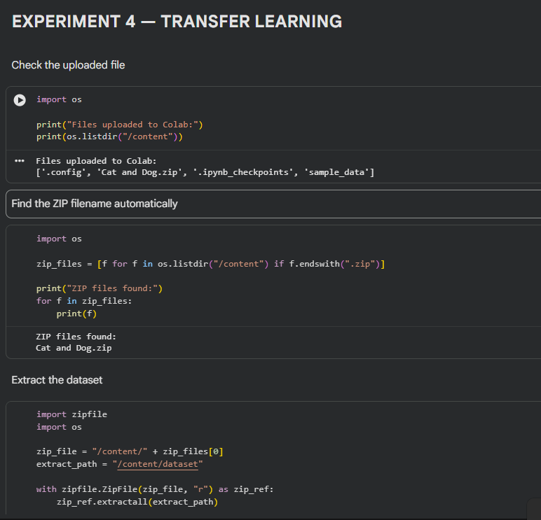
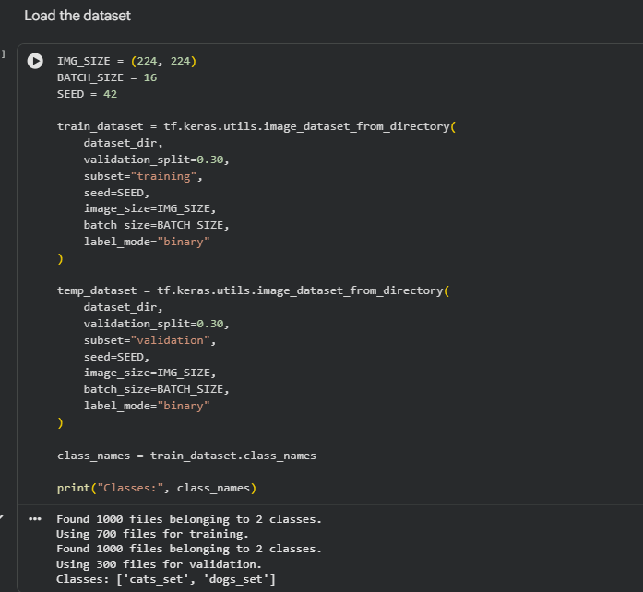
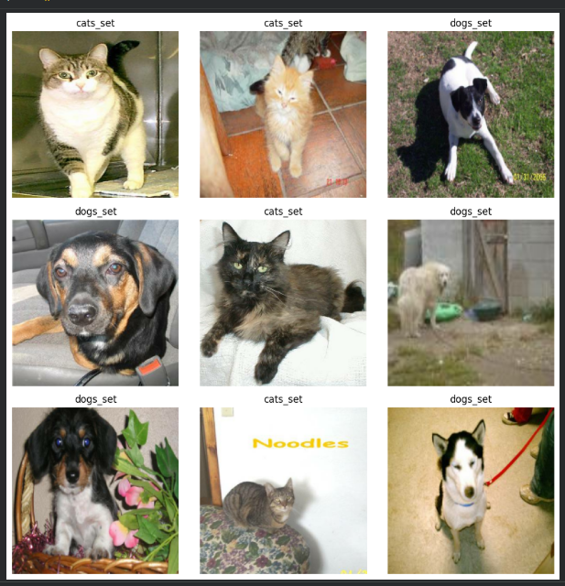
Task B: IMPLEMENTING TRANSFER LEARNING
Load a pre-trained model such as:
- ResNet-50
- AlexNet
Replace the final classification layer according to the dataset classes.
Freeze the feature extraction layers.
Compile the model.

Code and Output:
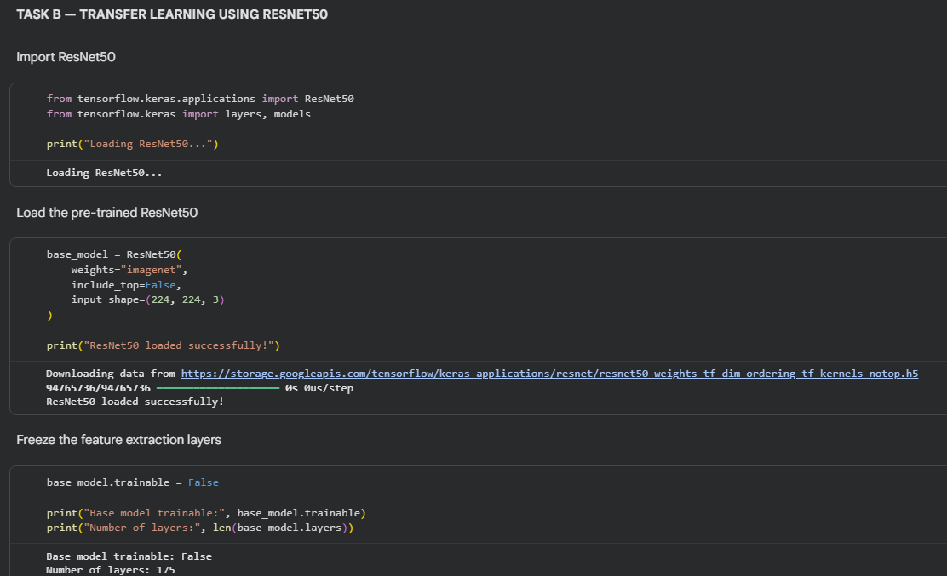
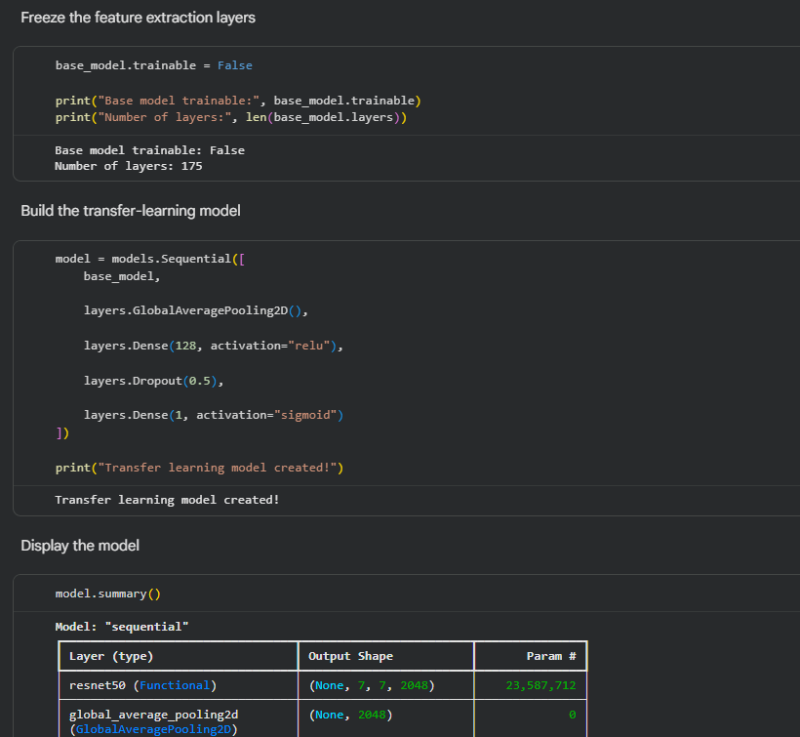
Task C: MODEL TRAINING AND PERFORMANCE EVALUATION
Train the transfer learning model.
Record:
- Training accuracy
- Validation accuracy
- Training loss
- Validation loss
- Test accuracy
Visualize:
- Accuracy vs Epoch
- Loss vs Epoch

Code and Output:
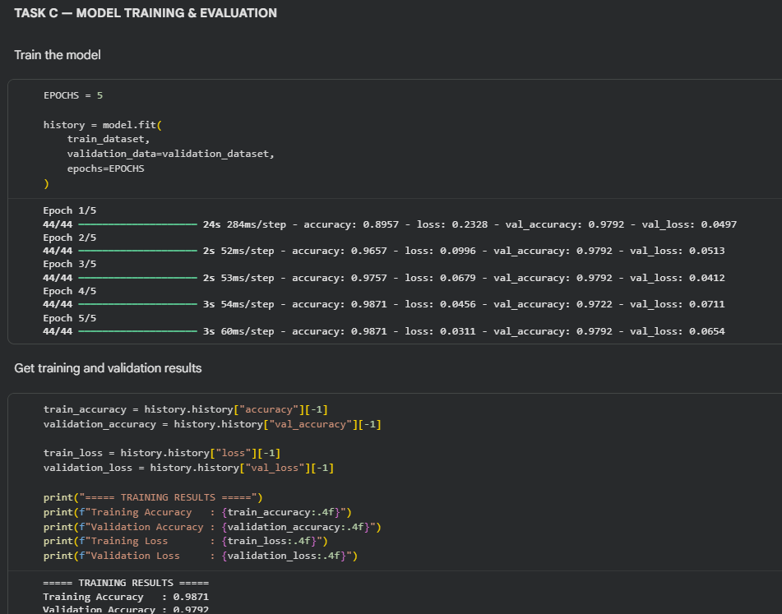
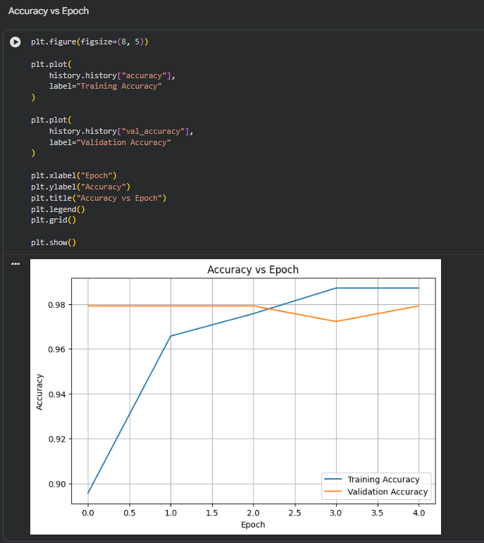
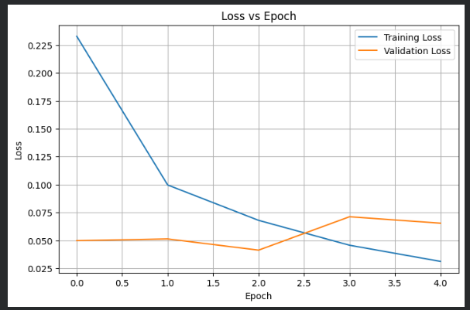
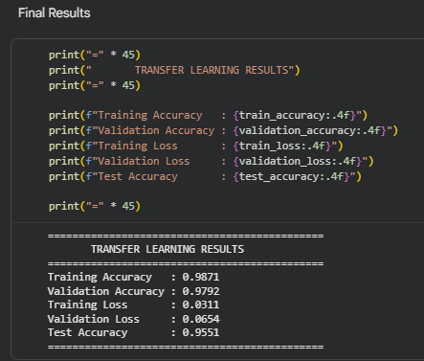
Task D: USING HUGGING FACE PRE-TRAINED MODELS
Perform the following tasks:
- Load a pre-trained vision model from Hugging Face.
- Perform image classification on sample images.
- Compare predictions with the transfer learning model.
- Document observations and upload the notebook to GitHub.

Code and Output:
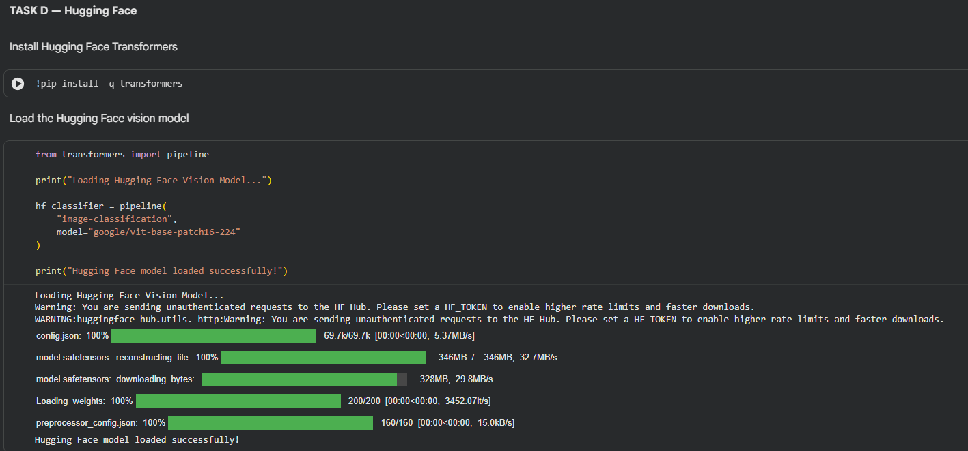
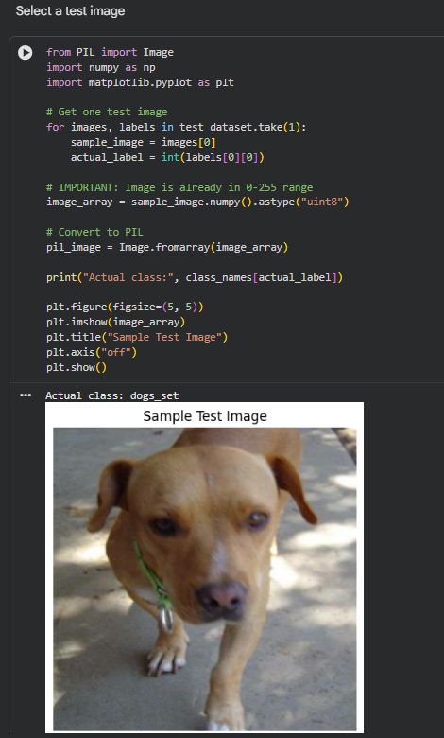
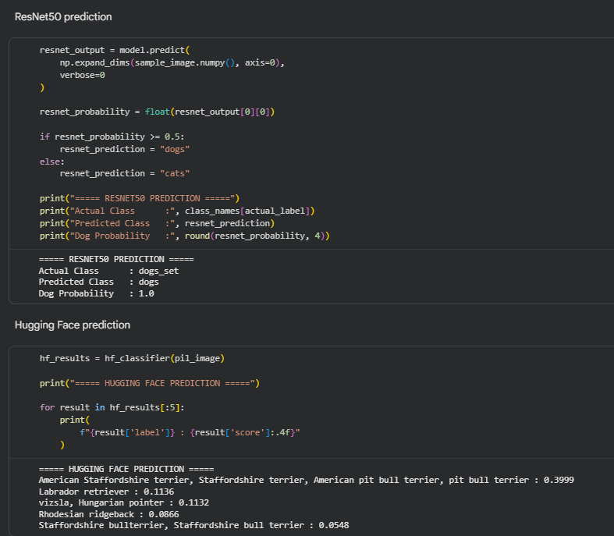
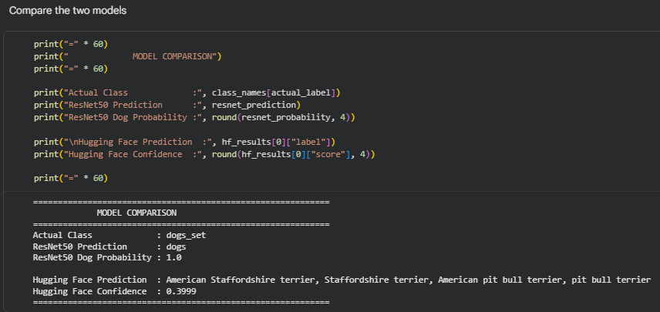
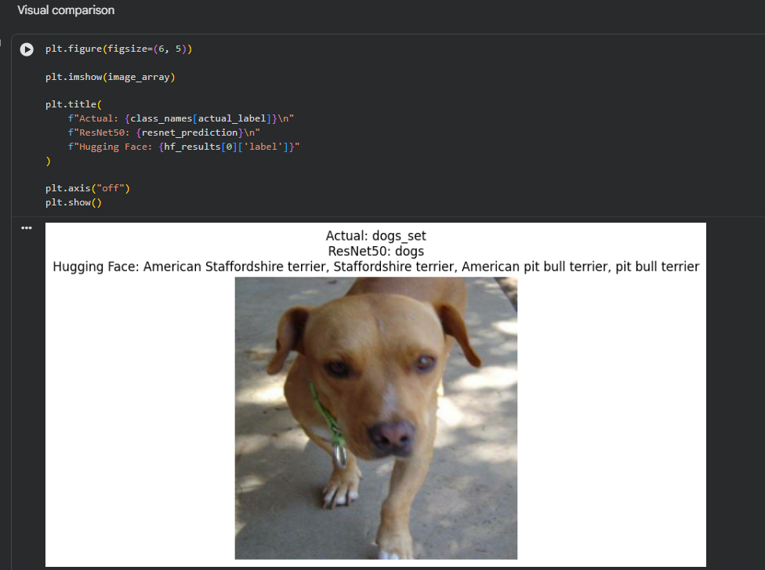

POST-LAB QUESTIONS (PROVIDE BRIEF ANSWERS TO THE FOLLOWING QUESTIONS)

- What are the advantages of transfer learning compared to training a CNN from scratch?
Transfer learning reduces training time and computational requirements because the model already has useful learned features. It generally needs less data and fewer epochs to achieve good accuracy. It also provides better performance and makes it easier to develop an image classification model.

- Why are pre-trained models able to achieve higher accuracy with fewer training epochs?
Pre-trained models have already learned useful features such as edges, shapes, textures, and patterns from large datasets. Therefore, they do not need to learn these basic features again. With fewer epochs, the model can adapt these existing features to the new dataset and achieve high accuracy.

- Compare the performance of the transfer learning model with the CNN implemented in the previous experiment.
The transfer learning model generally performs better than a CNN trained from scratch because it uses features learned from a large dataset. In this experiment, the ResNet50 model achieved 95.51% test accuracy, showing effective image classification with relatively few training epochs.

- What is the purpose of freezing layers during transfer learning?
Freezing layers prevents the pre-trained feature extraction layers from changing during training. This preserves the useful features already learned from the original dataset. It also reduces the number of trainable parameters, making training faster and requiring fewer computational resources.

- How can Hugging Face simplify the deployment and experimentation of vision models?
Hugging Face provides ready-to-use pre-trained vision models, datasets, and libraries. It allows users to load and test models easily without implementing them from scratch. This simplifies image classification experiments, model comparison, and deployment while reducing development time and complexity.

GitHub Link:

ASSESSMENT
Description | Max Marks | Marks Awarded
Pre Lab Exercise | 5
In Lab Exercise | 10
Post Lab Exercise | 5
Viva | 10
Total | 30
Faculty Signature

